*SignUp Genius
https://www.signupgenius.com/

The FREE version of SignUp Genius is sufficient for our needs. It allows me to set up all the slots I need, ask information from the users like student name or ID#, and mass email all registered. I looked into other programs, but this was by far the most user friendly. Here is the example.

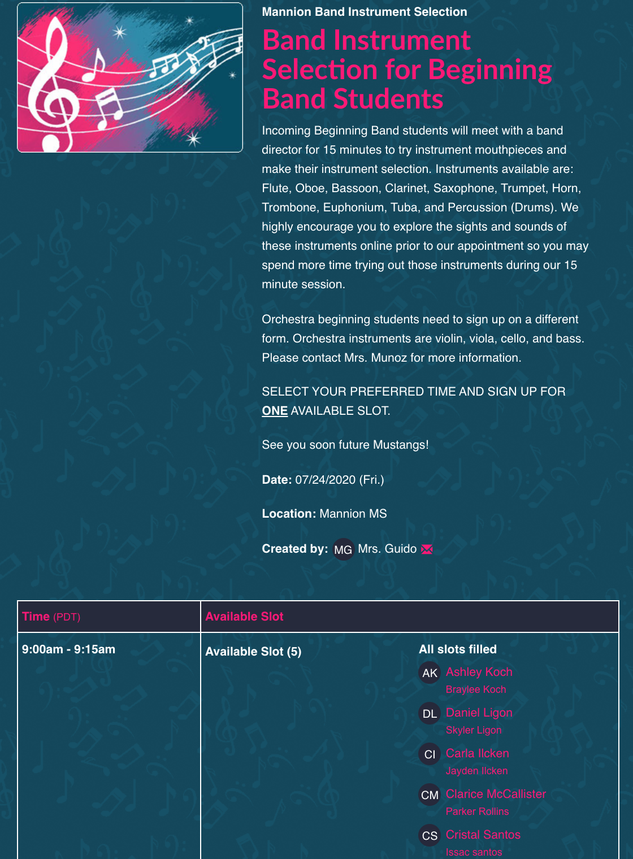

INSTRUMENT DEMONSTRATION VIDEOS

We also used the US Army Field Band instrument demonstration video for students that didn’t have an idea of what instrument to play. I sent this link to individual students and parents, but in hindsight I should have sent it out in the initial email.
https://youtu.be/CCTeSjpDsIs

I love their descriptions of the instruments, their excerpts, and Stars and Stripes at the end which allows them to see what it sounds like when the instruments play all together. I only wish there was something like this but with HS students demonstrating the instruments. Young kids love watching the older kids I think. :)

*For directors who can’t physically see the students or have families that don’t feel comfortable attending an event like this, I suggest that they use the Stiles Middle School Google form to obtain information that is going to help the director decide what instrument the student wants to play and would best fit the student’s physical attributes. Here is the link to that form: https://drive.google.com/file/d/1shQhGz45eq4pO2ggTf8g1Q1B_kNsD-hY/view

I think the same process would work if directors wanted to see the students on zoom or google meets. The questionnaire could be sent out ahead of them, then the SignUp, then meet with each student via zoom or google meets. Some directors have expressed concerns about not being able to meet the student and see their lips, or how tall they are, or their teeth. A zoom/google meet could help.

Instrument Selection - I’m adding two instrument selection handouts I’ve used for years. One is Erin Cole’s handout from her Midwest Clinic session that may help if directors are able to see their students. The other by John Benzer includes very detailed physical characteristics needed for each instrument that will help if the director can’t meet with the student and only place students with a questionnaire.

